University of Washington

iSchool Info 330

# Module 02 Assignment - Enhancing a Database

In this module's assignment, you will learn how database designs are improved with the addition of constraints and abstraction layers.

## Assignment Videos

Please watch the following Videos:

|  |
| --- |
| Assignment Videos < 120 min (Links are to external sites) |
| [Common DB Options - Constraints - 45](https://youtu.be/A8pUl-BWRYg) |
| [SQL Data Definition Language - 18](https://www.youtube.com/watch?v=NxhJzdMQnlQ) |
| [Using a Metadata Spreadsheet](https://youtu.be/angniIotJW4) - 2 |

## Assignment Examples

Read and try out some SQL statements on the W3Schools website. In many of these articles, you will find a "Try it Yourself" section where you can experiment with the SQL language interactively.

This website will become one of your most-used "Go-To" sites as you progress in your learning. So please check out the following pages this week!

|  |
| --- |
| Examples < 60 min (Links are to external sites) |
| [SQL Constraints - 5](https://www.w3schools.com/sql/sql_constraints.asp) |
| [SQL Not Null - 5](https://www.w3schools.com/sql/sql_notnull.asp) |
| [SQL Unique - 5](https://www.w3schools.com/sql/sql_unique.asp) |
| [SQL Primary Key - 5](https://www.w3schools.com/sql/sql_primarykey.asp) |
| [SQL Foreign Key - 5](https://www.w3schools.com/sql/sql_foreignkey.asp) |
| [SQL Check - 5](https://www.w3schools.com/sql/sql_check.asp) |
| [SQL Default - 5](https://www.w3schools.com/sql/sql_default.asp) |
| [SQL Index -5](https://www.w3schools.com/sql/sql_create_index.asp) |
| [SQL Auto Increment -5](https://www.w3schools.com/sql/sql_autoincrement.asp) |
| [SQL Views -5](https://www.w3schools.com/sql/sql_view.asp) |

## Assignment Reading

Since the course does not have an official text you will use various websites for your studies. This is a great way to learn new subjects and practicing it will be something you will use for years to come! Please read the following web pages:

|  |
| --- |
| Reading < 120 min (Links are to external sites) |
| <https://en.wikipedia.org/wiki/Relational_model> - 60 |

## Assignment Task

In this assignment, you practice what you have learned in this module by designing and creating another database called **Assignment02DB_YourNameHere**. The database needs to hold the following data. This is like the last assignment, but this time your script will include both constraints and views.

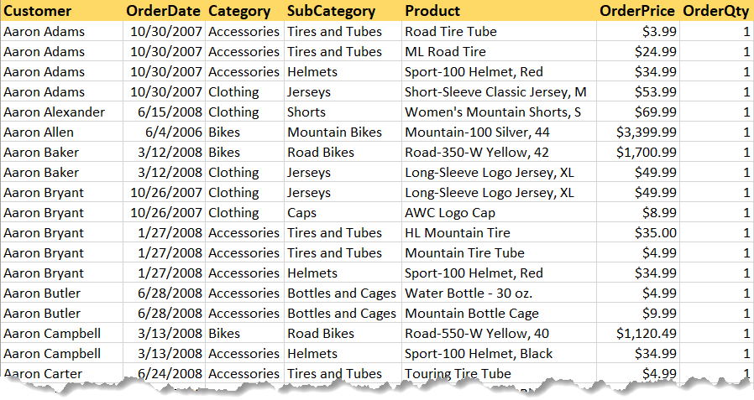

NOTES:

* This database must include tables with proper constraints and views for an abstraction layer.
* You **do not need to fill the tables** with data in this assignment!
* Make sure you place a developer **header at the top of your script**.
* **Create an ERD** of your new database
* **Create a Metadata Worksheet**

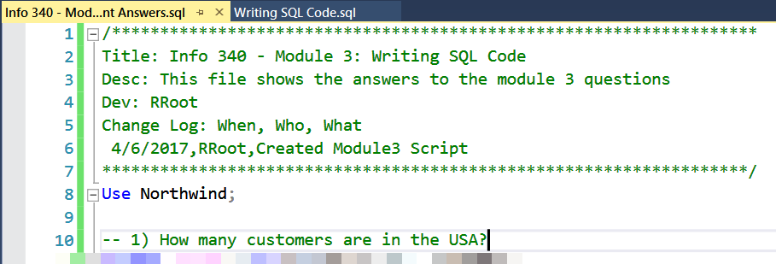

# Grading

Student work will be evaluated on a point system using the following general guidelines found on the Course Syllabus page. Make sure you read and understand this.

**NOTES:**

* It is very possible to get a 3.9 or better from this course, but you must earn it! Do not expect **to get 100%** of the possible points without extra effort on your part. If you want to excel in this course, **you must submit excellent work**!
* Not putting your name, course, and date at the top of the ERD document you will cost your 25% of your grade.

# Submit your work

After you have completed your **ERD document, Metadata worksheet**, **and SQL Script,** place both into a folder called Assignment02_**FirstInitialLastName** and Zip the folder. Upload the Zipped folder to the Canvas web site.

